Ceramic Coating Weapons
$Price List$

RIFLE - BOLT ACTION
CERAKOTE CERAMIC COATING
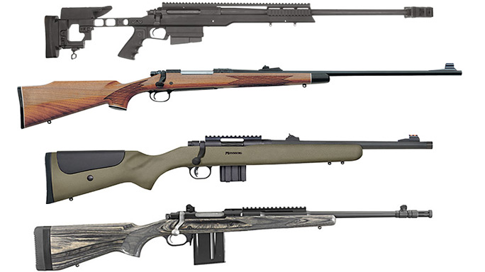

Bolt Action Rifle - Single Colour
COMPLETE RIFLE
Includes barrel, receiver & bolt $225.00
DISASSEMBLY / REASSEMBLY $90.00
BARREL $75.00
BARRELED ACTION $175.00
STOCK $120.00
BOLT $50.00

RIFLE - AR15 | PUMP | SEMI-AUTO
CERAKOTE CERAMIC COATING
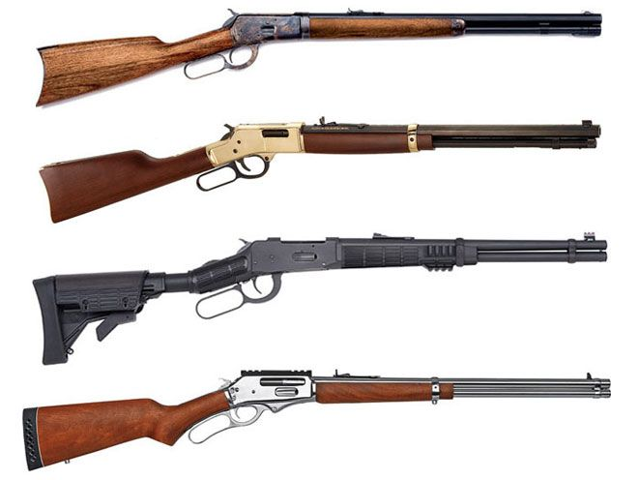

AR15 | Pump Action | Semi-Auto Rifle - Single Colour
COMPLETE RIFLE $250.00
DISASSEMBLY / REASSEMBLY $90.00
QUAD RAIL - PER INCH $6.00
UPPER $80.00
LOWER $80.00
STOCK $65.00
MAGAZINE $25.00
GRIP $25.00
BARREL & GAS BLOCK $80.00
V2 / CS METAL FOLDING STOCK $50.00

SHOTGUN
CERAKOTE CERAMIC COATING
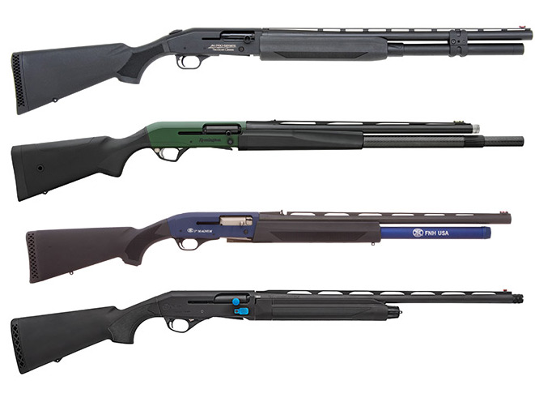

Most Shotguns - Single Colour
COMPLETE SHOTGUN $225.00
DISASSEMBLY / REASSEMBLY $90.00
STOCK $65.00
FOREARM $60.00
RECEIVER $80.00
VENTED HAND GUARD $50.00
SINGLE BARREL $75.00
DOUBLE BARREL $150.00

PISTOL
CERAKOTE CERAMIC COATING
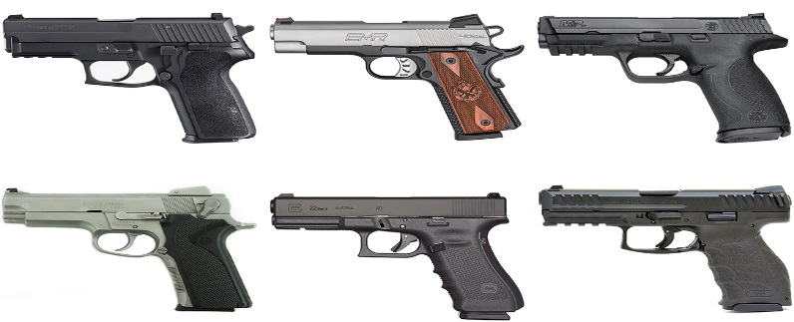

Pistols - Single Colour
COMPLETE PISTOL $250.00
STI / SVI 2011 $300.00
PISTOL DISASSEMBLY / REASSEMBLY $80.00
REVOLVER DISASSEMBLY / REASSEMBLY $100.00
SLIDE $80.00
SLIDE DISASSEMBLY $40.00
FRAME $90.00
2011 FRAME $80.00
FRAME DISASSEMBLY $40.00
MAGAZINES $25.00
GRIPS $25.00
2011 GRIPS $50.00
BARREL $50.00

CAMO | MULTI-COLOURS
CERAKOTE CERAMIC COATING
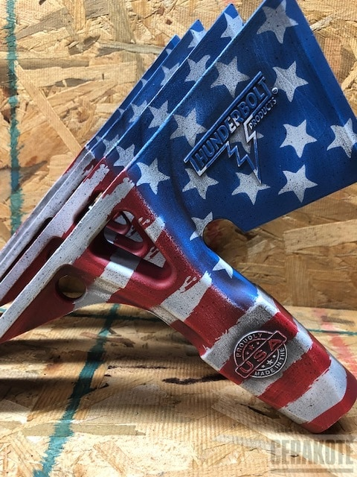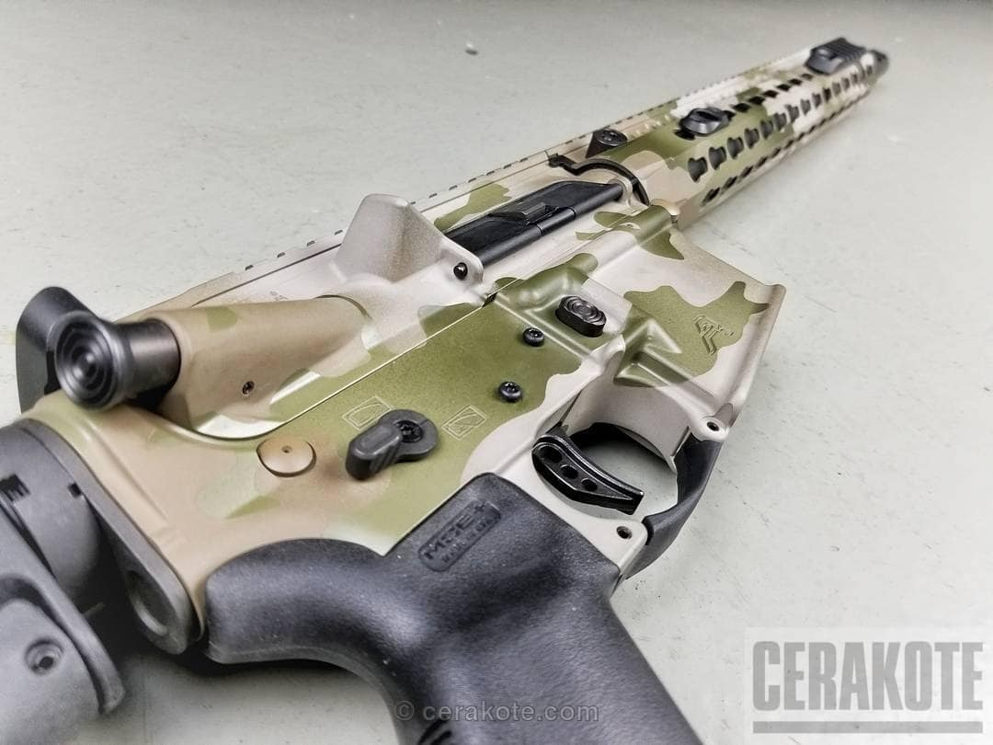

Camo / Multi-Colour
3 COLOUR RIFLE / SHOTGUN $450.00
3 COLOUR PISTOL $350.00
FRAME $200.00
SLIDE $200.00
ANY COLOUR CHANGE $40.00

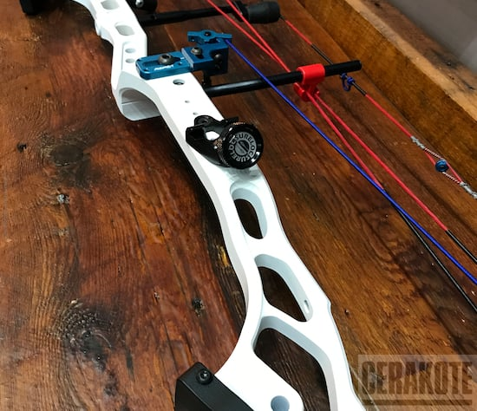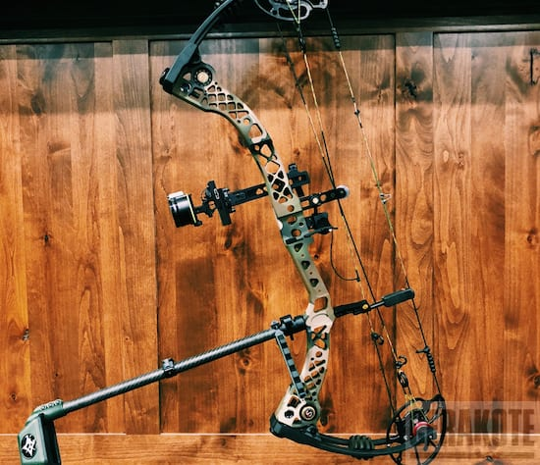

Bows -must ship disassembled
Bow – Recurve $160
Limbs/Riser - Solid Color
Battleworn add $40
Must ship disassembled

Bow – Compound $250
Limbs/Riser/Cams/Stabilizer - Solid Color
Battleworn add $40

Bow – Riser $100
Solid Color
Battleworn add $20

Suppressor $70
High Temp - Solid Color

Magazine $25
Body, Floor Plate - Solid Color
Battleworn add $20

